**GT® Timing Belts and Pulleys**

The PowerGrip GT2 Belt Drive System is an advance in product design over the Gates‘ older, standard HTD system, providing higher torque carrying capability and improved load carrying strength.

The PowerGrip GT3 Belt Drive System is the newest design and offers additional benefits over GT2. The improved construction and material compound provides superior load bearing capacity. The GT2 Belts are being phased out and replaced by the new GT3 Belt Drive System

Both the PowerGrip GT2 and GT3 System‘s deep tooth design increases the contact area which provides improved resistance to ratcheting. The modified curvilinear teeth enter and exit the pulley grooves cleanly, resulting in reduced vibration.

These belts and pulleys are available in 2 mm, 3 mm & 5 mm pitches and provide the following advantages:

Longer belt life

Precision registration

Increased load-carrying capacity

Quieter operation

Precise positioning

Application Examples for the PowerGrip GT2 and GT3 drive systems: Machine Tools, Hand Power Tools, 3D-Printers, Medical Diagnostic Equipment, Automated Teller Machines, Robotics Equipment, and Vending Equipment.

The efficiency and integrity of a belt drive is closely attributed to the quality of pulleys involved. The pulleys therefore, should be supplied by qualified and licensed suppliers. Stock Drive Products is licensed by Gates. The GT2/GT3 pulleys manufactured by Stock Drive Products are made using licensed hobs, achieving the precise fit for the drive system. The pulleys offered here will mesh perfectly with either the GT2 or GT3 belt.

HTD is more commonly used as they are cheap and easily tooled because of its rounded teeth

GT2 is can also be used with proper model

Instead of concerning the maximum allowable torque on the pulleys, torque rate on timing belt is more critical.

GT3 belt can be used on GT2 sprocket and pulleys

Selection:

If GT2 belt is selected, then 5mm pitch is needed for torque greater than 10Nm, and 15mm belt width is enough.

If select GT3 belt, then 3MGT is suitable, however suitable width is 15mm and 5MGT can be used

From the CAD, belt is approximately 400mm

9mm width 5mm pitch HTD belt is also appropriate and there wouldn’t be any waste of strength

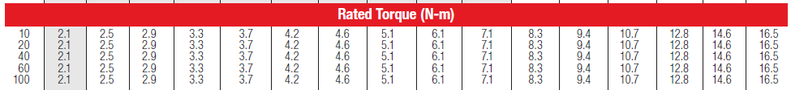

Myomo pro big pulley has 80 teeth 5mm pitch, small pulley has 16 teeth